Instructions for Robotic Arm Debugging
Preparation
First connect the wires according to the instructions and calibrate the robot arm.

Achieve up and down motion at any angle
Use the combined instruction to achieve up and down movement
After calibrating
Input G95
Input G1 Z90 , 90 is the angle of rotation around the Z axis, which can be modified.
Input G94
Input G1 Z10, 10 is the coordinate in the Z-axis direction, which can be modified.
The input command indicates that the coordinate is 10 in the Z direction, and the X and Y coordinates are kept unchanged.
Up and down movements are achieved through this series of commands.

It should be noted that in the G95 angle mode, G1 is in the relative movement mode( the corresponding distance is moved in the opposite direction). The default motion mode of G94 is absolute motion mode, and the G1 command will move to the corresponding coordinate point.

To achieve up and down repeat motion with specific instructions
The preset commands G5, G7 helps to achieve the up and down movement of the cycle number, angle and speed.
First, adjust the arm to the appropriate coordinates,
Enter the G7 command to adjust the parameters:
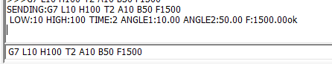

Here, L represents the lowest point Z coordinate of the Z axis of the relative angular coordinate system, and H represents the highest
A and B represent the two angular coordinates corresponding to the Z coordinate of the angular coordinate system. After setting, the robot arm will move up and down at these two positions respectively.

T represents the number of cycles
F stands for sporty speed.
After setting the parameters, input G5, the robotic arm starts the specified action.
